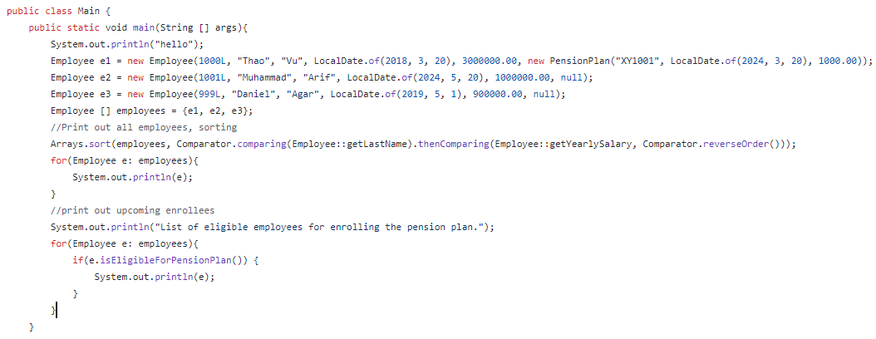

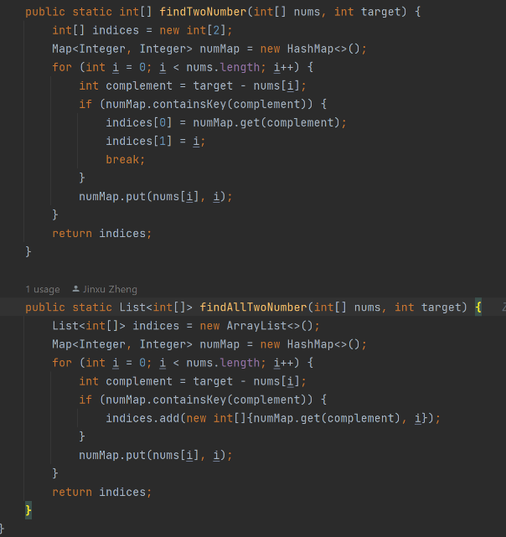

mysql -u username -p

USE database_name;

CI/CD stands for Continuous Integration and Continuous Delivery/Deployment. It's a set of practices and tools that enable software development teams to deliver code changes more frequently and reliably.

Spring Boot builds upon the Spring platform, providing developers with pre-configured settings and conventions to create applications more efficiently. What is the relation between Spring platform and Spring framework?The Spring framework is the foundation of the Spring platform, which includes various tools like Spring Boot, Spring Data, and Spring Security, built upon it. What is Dependency Injection and how is it done in the Spring platform/framework?Dependency Injection (DI) in Spring is about providing objects (dependencies) to a class from outside rather than creating them inside the class.This is done automatically by Spring's container, making classes loosely coupled and easier to manage. You can inject dependencies using constructor, setter methods, or directly into class fields with annotations like @Autowired. This makes your code more modular and easier to test.What is Inversion of Control (IoC) and how is it related to Spring?Inversion of Control (IoC) means that instead of your code creating and managing objects directly, a framework like Spring takes care of it for you.In Spring, the IoC container manages the creation and configuration of objects, making your code more modular and easier to maintain.

